Mohammed Mujahed Batch-16
1) Enable cloudtrail monitoring and store the events in s3 and cloudwatch log events.
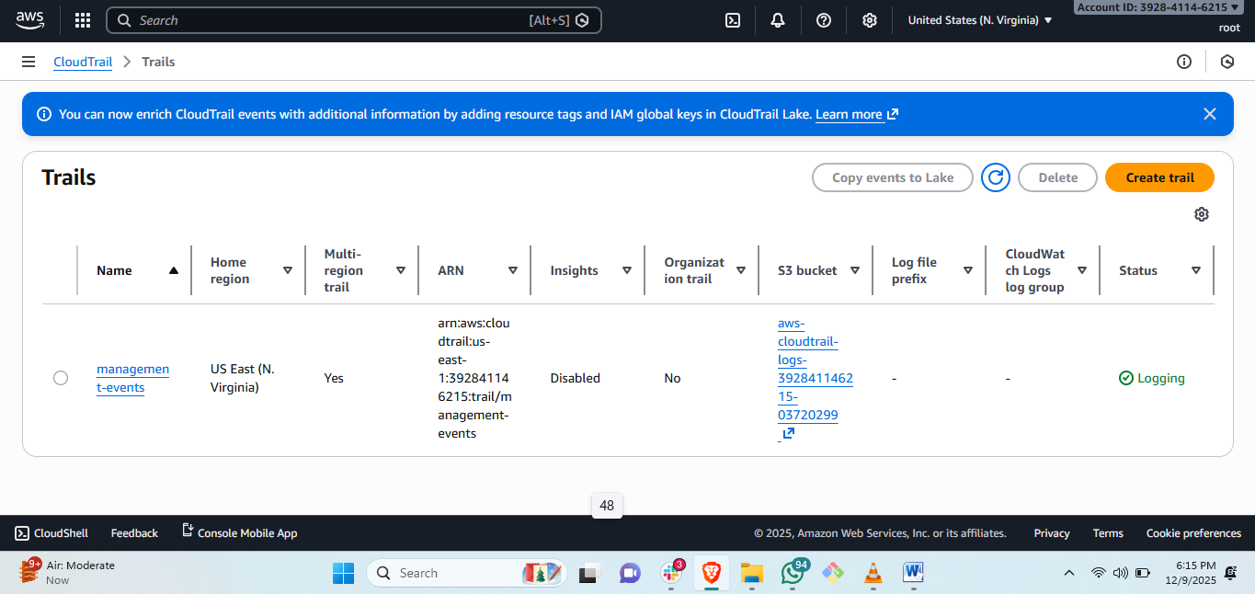
steps: created cloudtrial just by default and save the logs in s3 bucket.
2) Enable SNS for cloudtrial to send alert on email.
purpose: to create the cloud trial and enablbing the SNS for tracking the history and adding the email for alerts through mail so that we can..
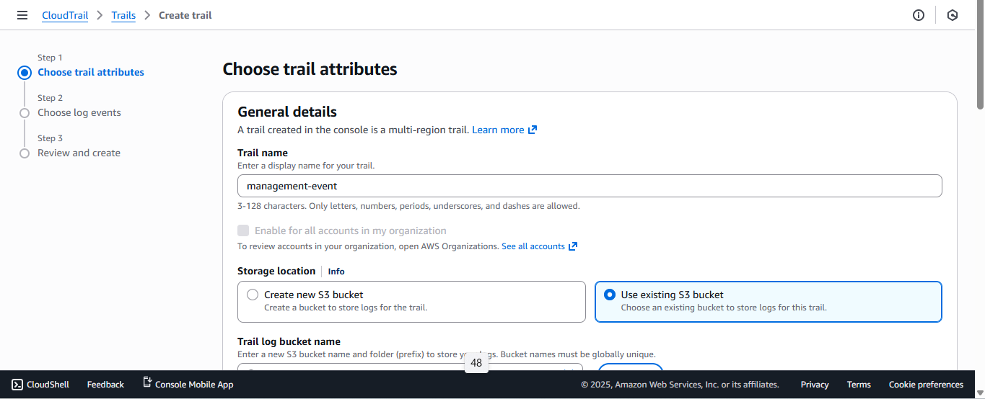
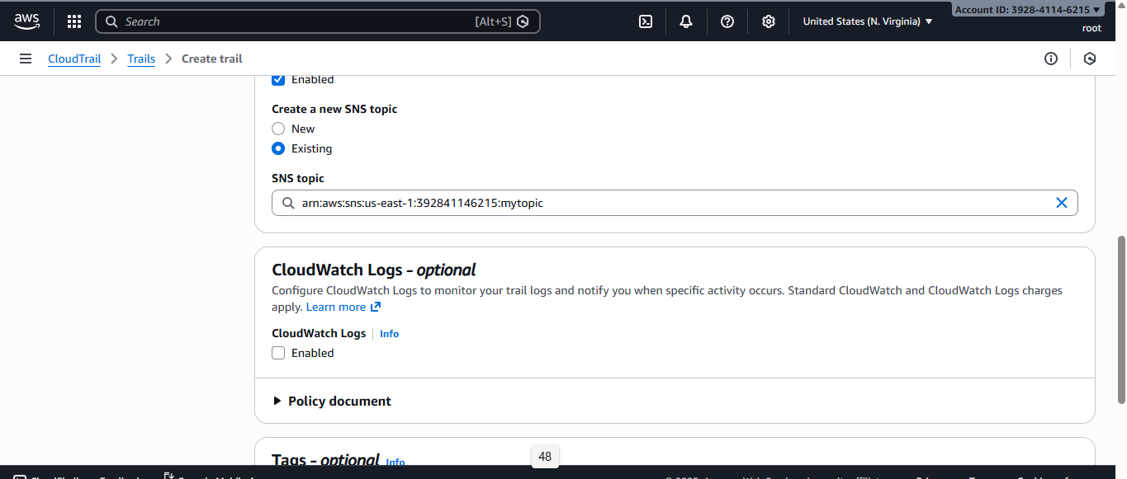
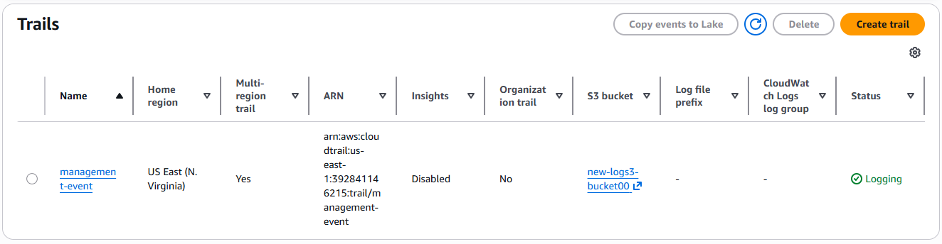
steps: first we search cloudtrial and create trial.
# then select standard and assign name and select the exsisting s3 busket to save logs.
#then then enable SNS and create SNS and select exsisting SNS.
#then create cloud trial with amanagement event for monitoring the aws resources.
3) Configure cloud watch monitoring and record the cpu utilization and other metrics of ec2.
purpose: the cloudwatch service is used to monitor the matric for AWS resource applications like- setup for getting mail on spu utilization and other monitoring tomcat application is available or not.
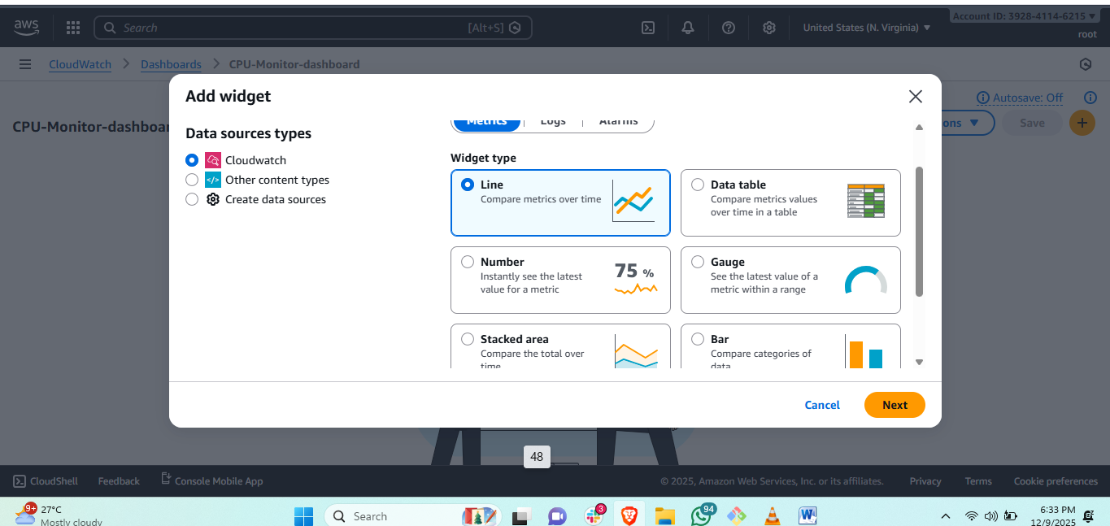
first go to cloud watch and create dashboard and select the numbers.
#then
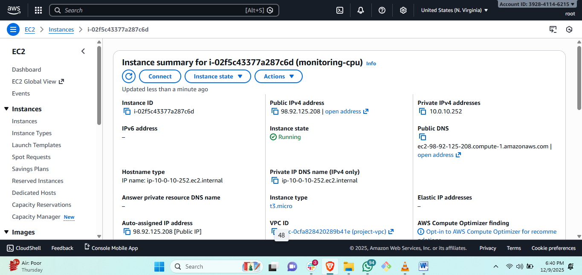
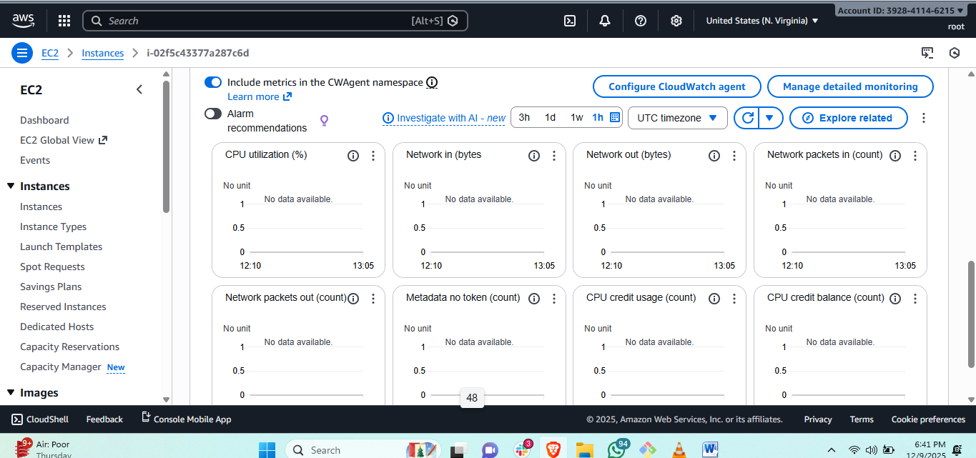
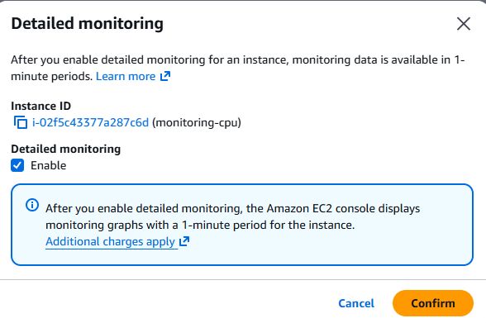
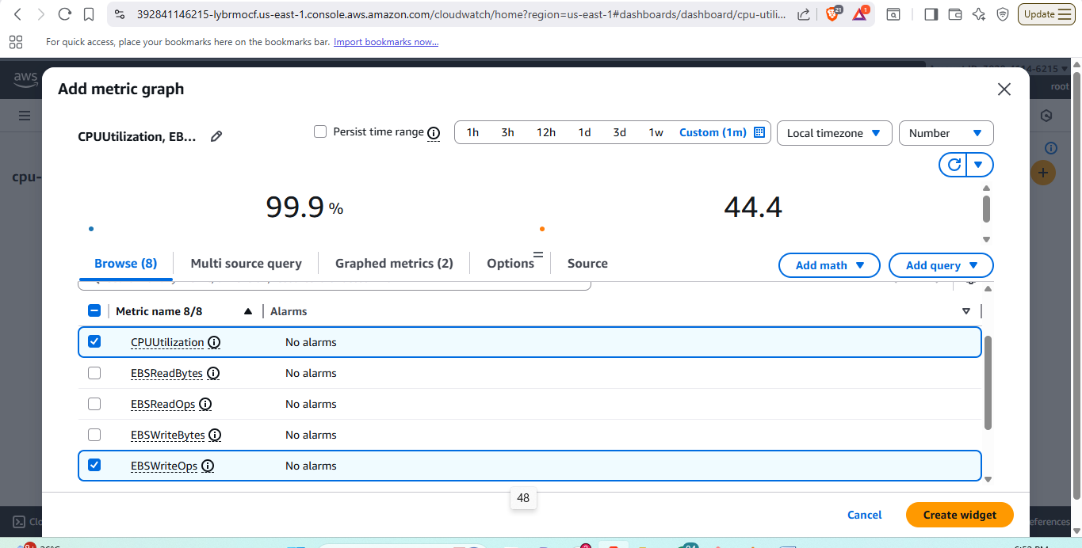
steps: first we have to create an instance and then go to monitore and see the last update of iunstance is 5 min by aws.
#but to check in every 1 min we enable monitoring then
#go to cloud watch service.
#then create dashboard with name.
#select the numbers for the usage checking then click create.
#then select for which service we are attaching the logs and mail
#select ec2 and paste the instance id and select the cpu and set time on what time it should be update.
4) Create one alarm to send alert to email if the cpu utilization is more than 70 percent.
purpose: we are creating the alarm for notification on cpu utilization above 70% where we can get mail directly to save the server or extent configuration.
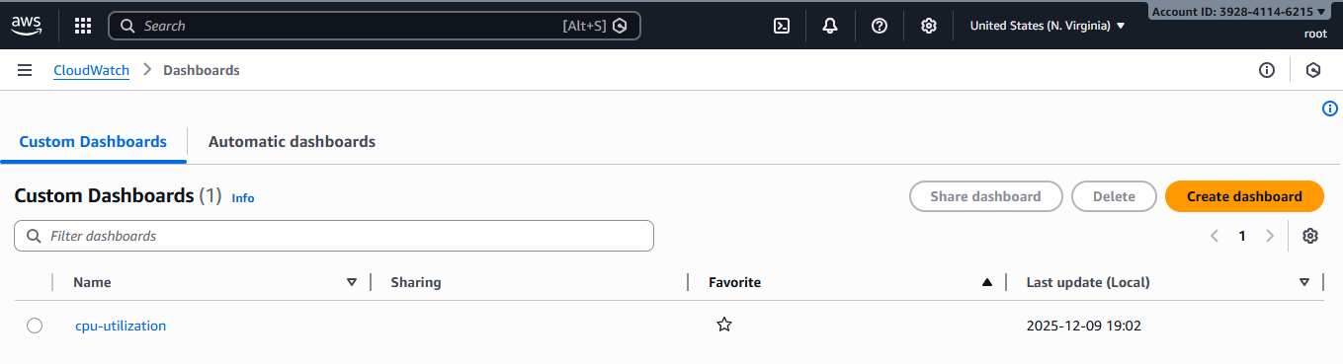
first go to cloudwatch.
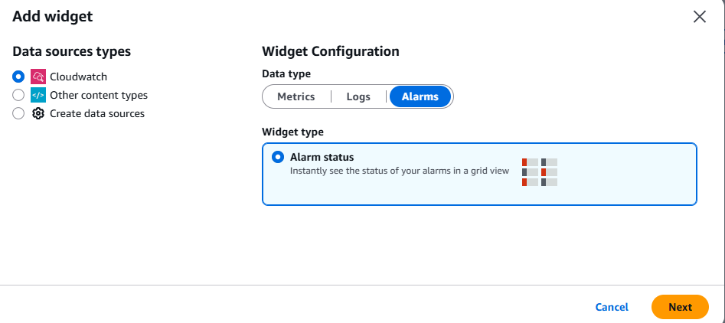
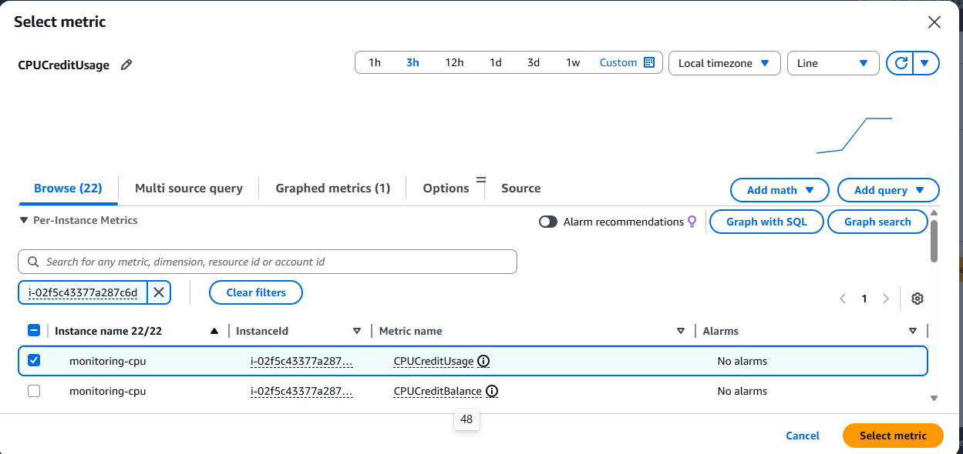
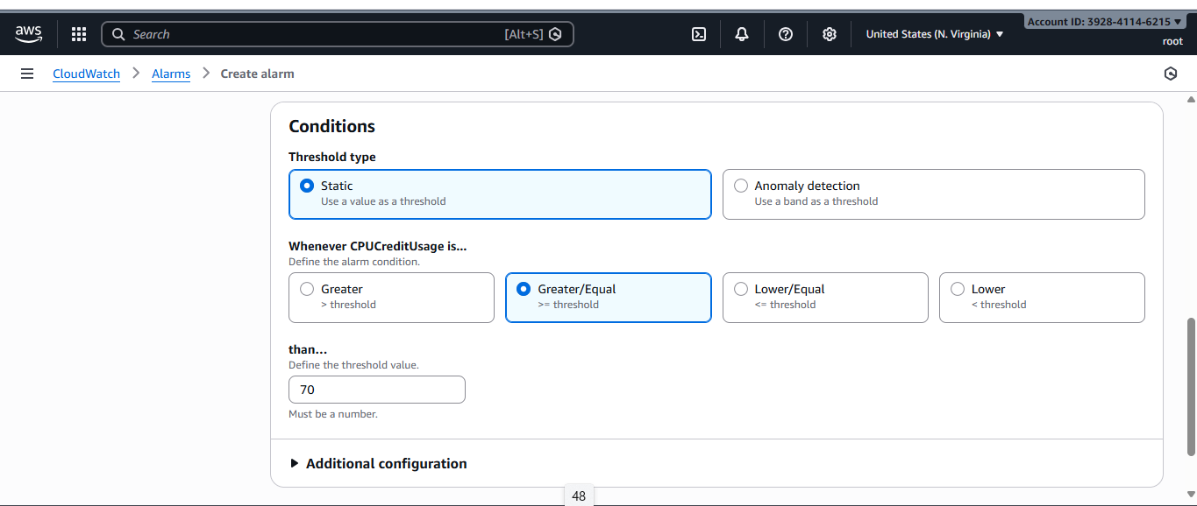
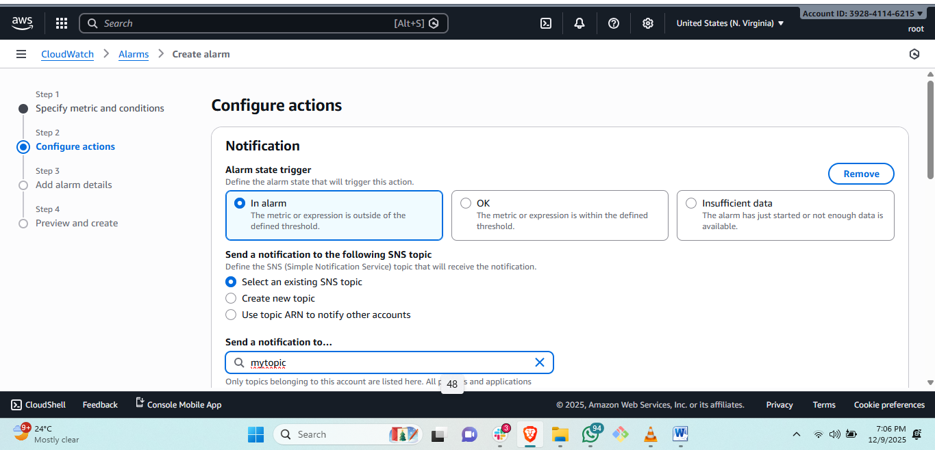
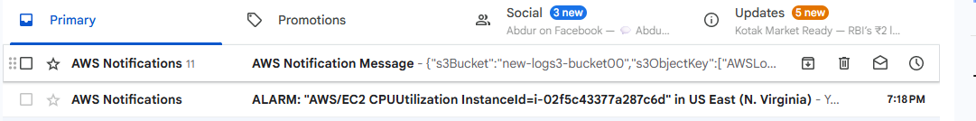
steps: first need to create a instance and enable set monitoring thorugh instance setting.
#then go to cloud watch and create a dashboard and select the number and then go to alarm in cloud watch and create alarm.
# then select the ec2 > and paste instance id and select.
#set the percentange how much cpu is utilized and get message.
#then enable alarm and create and refresh see i
5) Create Dashboard and monitor tomcat service wether it is running or not and send the alert.
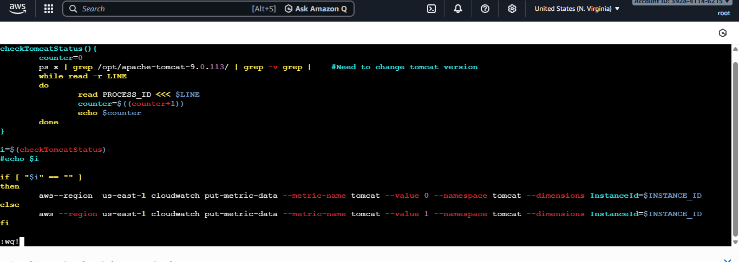
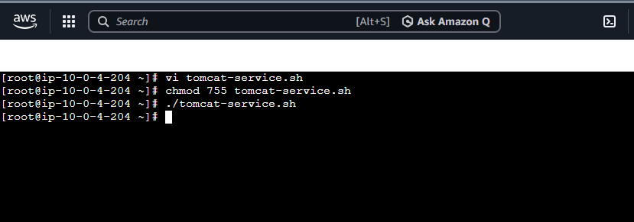
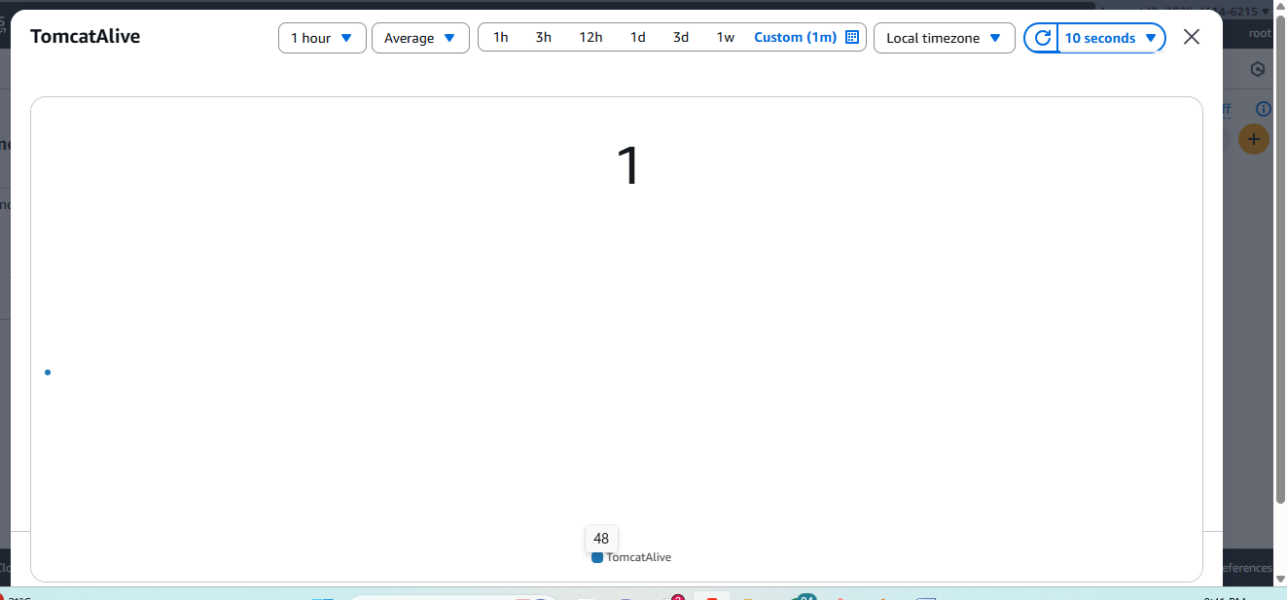
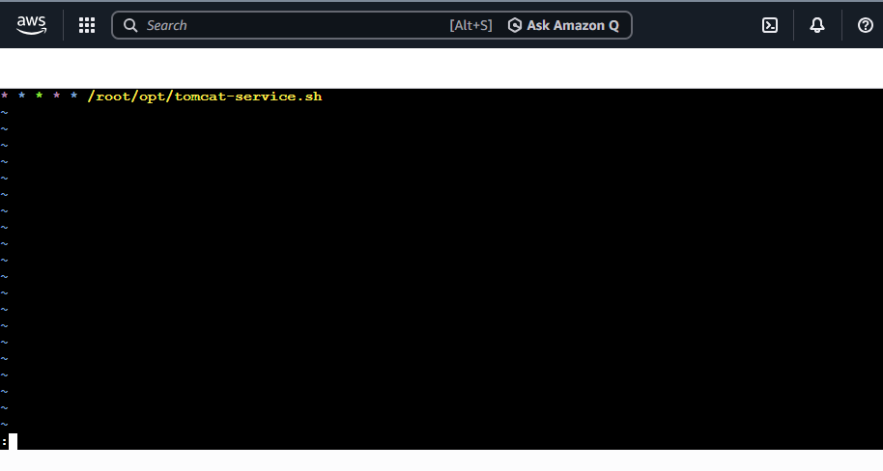
steps: first we create a ec2-instance and then setup nginx in it.
#then run script for defining values if tomcat is running then number will 1 if not running it should be 0 as it shows.
#then go to cloud watch and create a dashboard and select number and then paste instance id and select the time for minimum 1 minuete it will change status.
6) Create Dashboard and monitor nginx service to send the alert if
nginx is not running.
purpose: for checking the status and running the nginx service and monitor throghy cloud watch we use this.
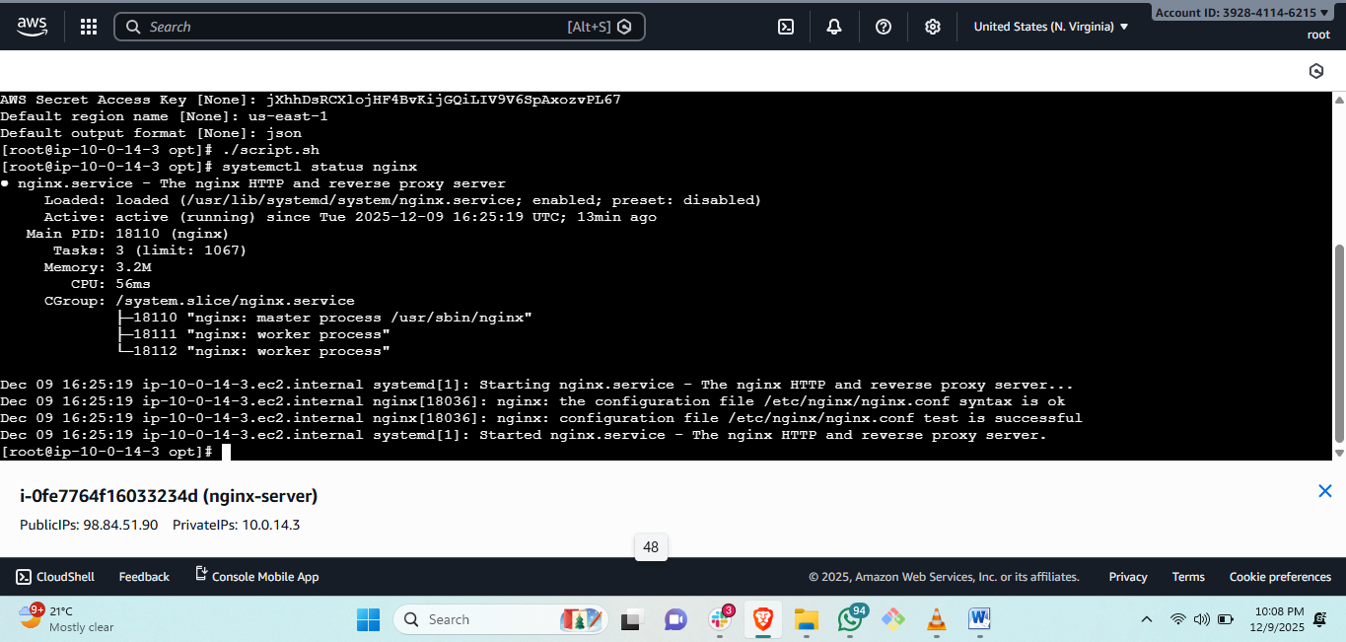
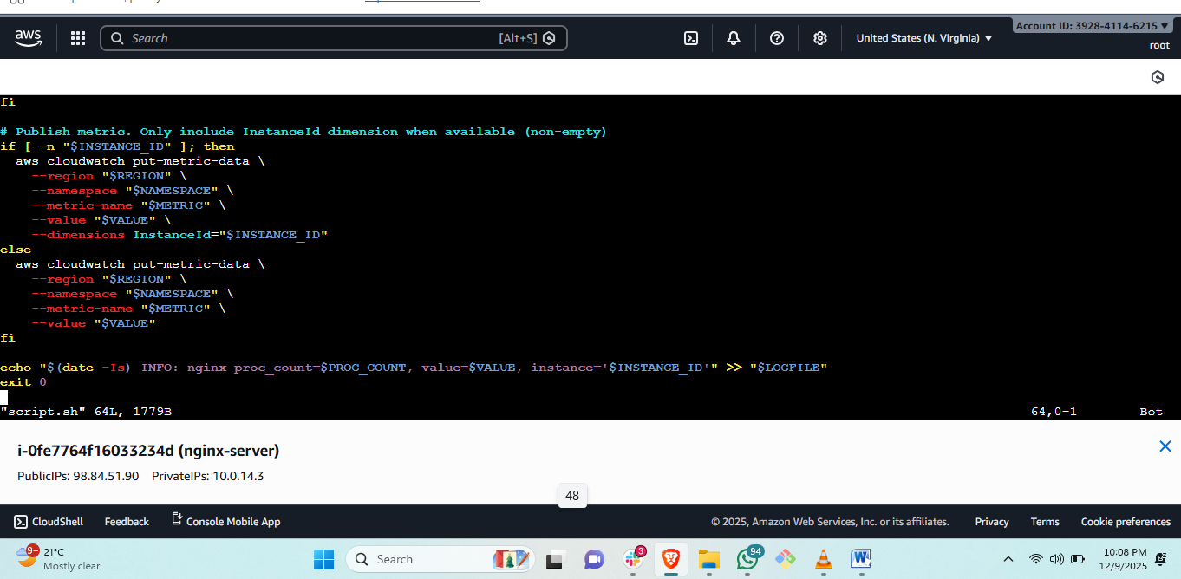
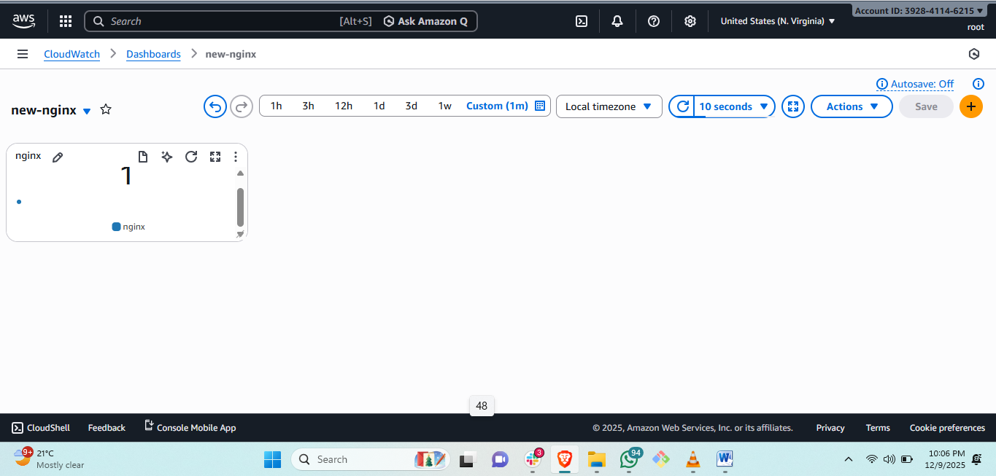
steps: first we create a ec2-instance and then setup nginx in it.
#then run script for defining values if Nginx is running then number will 1 if not running it should be 0 as it shows.
#then go to cloud watch and create a dashboard and select number and then paste instance id and select the time for miimum 1 minuete it will change status.

